Saturday In The Park
Capo:

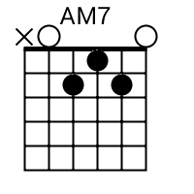
[Intro] Em7 A7 C G

[Verse 1]
Em7 A7
Saturday in the park
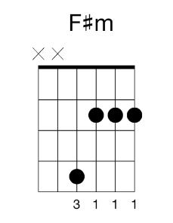
C/D G
I think it was the Fourth of July (2x’s)
F#m Bm Bm7
People dancing, people laughing
Amaj7
A man selling ice cream
G E5 A5
Singing Italian songs
D C/D
Ei-cay va-ré, ei-sé nar-dé
G/D D
Can you dig it, yes I can
Em7
And I've been waiting such a long time
A7
For Saturday [Interlude] D G

[Verse 2]
Em7 A7
Another day in the park
C/D G
I think it was the Fourth of July (2x’s)
F#m Bm
People talking, really smiling
Amaj7
A man playing guitar
G E5 A
And singing for us all
D C/D
Will you help him change the world
G/D D
Can you dig it, yes I can
Em7 A7sus2 A7
And I've been waiting such a long time for today

[Bridge]
F/G G* F/G G*
Slow motion riders
F/G G* F/G G*
Fly the colors of the day
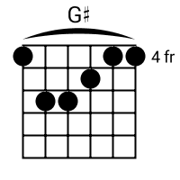
G#
A bronze man still can

Tell stories his own way
C/D D C/D D
Listen children all is not lost
C/D D C/D D
All is not lost, oh no

[Instrumental] Em7 E7sus4 A9 A7* Cmaj7/D C6/D G x2

[Verse 3]
Em7 A7 C/D G
Funny days in the park, and every day's the Fourth of July(2x’s)
F#m Bm Amaj7
People reaching, people touching, a real celebration
G E5 A D C/D
Waiting for us all, If we want it, really want it
G/D D
Can you dig it, yes I can
Em7 A7sus2 A7 End: D
And I've been waiting such a long time for the day

