  Kanahan |  |  |  |   Susaker
  herty |  | od  Sister of Terry Wood |  | 
Bacon |  |  |  |   acon  Husband of Rebecca Nicholls
 |  |  |  | rickson  Wife of Pete Erickeson
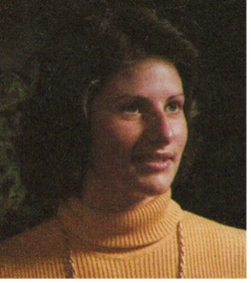
mpbell
Wife of Kevin Campbell

